# Incident Technical Report: Gear Wear Progression in Starboard Gear Train MG-5025A of Naval Vessel INS Haifa

## Executive Summary

This report documents a progressive tooth-wear event that developed in the MG-5025A marine reduction gearbox installed in the propulsion train of INS Haifa. Baseline “Healthy” recordings were collected in February 2023 (with no abnormal indications through 8 April 2023). The first onset of wear was detected on 9 April 2023 and was tracked across 35 sequential wear cases through 15 June 2023, when elevated noise and vibration culminated in a functional failure that necessitated shutdown.

Monitoring used accelerometers placed on gearbox housings adjacent to the input and output shafts, sampling at 50 kHz for 60-second windows per record. Recording intervals followed the actual time stamps in the site Database log; per session, it was indicated whether records were close (≈1 minute apart), spaced by minutes, or collected in morning/afternoon/evening clusters.

Across April–June, crews consistently reported louder gear noise under steady speed and a gradual rise in overall vibration level. Time-domain RMS, trended upward in step with the Wear Case 1 → 35 progression, the wear depth are labeled in Table 1 . The final day (15 June) showed a marked jump in amplitude and transient impulsive responses consistent with severe war liberation on a loaded flank, followed by immediate operational withdrawal.

Vibration signal processing and Image processing were performed for analysis. The gearbox transmission lubrication in service was 2640 semi-synthetic, 15W/40 viscosity. All signals were record at speed 45 RPS and 15 RPS.

## System Description

**Vessel and Transmission**: INS Haifa employs a conventional marine propulsion train. The subject gearbox is an MG-5025A naval reduction gear, configured as part of the ship’s main gear transmission. The investigated component is the primary reduction gear pair (driving gear and driven gear).

**Lubrication**: Sump and spray lubrication with 2640 semi-synthetic (15W/40) oil maintained to standard naval cleanliness targets. No bulk oil temperature logging was available for this investigation period.

**Operating Conditions**: Data were acquired at two steady speeds: 45 RPS (Full speed) and 15 RPS (Minimum).

**Instrumentation & Acquisition**: Two industrial accelerometers mounted on the gearbox casing near input and output shafts. The accelerometers direction measurements were at the gravity direction. 60-second time records, 50 kHz sampling rate.

**Imaging**: Following each measurement day, tooth-flank photographs were taken using a camera integrated with the inspection microscope available in the lab (images archived in the shipyard file and referenced internally to the daily session). Images served as qualitative corroboration of wear evolution (Healthy teeth → micro-wear → macro-wear). They are appeared in Figure 1

## Failure Progression

On February 13, a new data-acquisition chain was installed, commissioned, and verified on the MG-5025A gearbox aboard INS Haifa. The commissioning included channel polarity checks, sensor seating verification, and a short functional run at both operating regimes. The monitoring protocol established for all subsequent records was: 60-second time records, 50 kHz sampling rate, and timestamping according to the DATABASE log; intervals between records on this date ranged from 1–10 minutes during commissioning bursts (e.g., 13:32→13:33→13:34→13:35, then 13:49→13:50→13:53…) and later ~8–15 minutes during steadier operation blocks. Photographic documentation of the gear teeth was also initiated on this date using a high-magnification digital microscope camera for surface tracking.

In Time Domain Analysis, the RMS vibration levels at 45 RPS (and in later same-day checks at 15 RPS) were consistently low and steady, exhibiting the hallmark of a healthy drivetrain: no bursts, no intermittent spikes, and no slow drift. This low-variance RMS trace indicates:

1. Stable shaft alignment and no assembly errors.
2. No abnormal gear contact, or unbalance speed (speed fluctuations).

In Spectral Domain Analysis, the companion spectrograms and FFT snapshots captured during operation showed a narrow-band signature dominated by the gear transmission and shafts. Peaks were sharp and of low amplitude, with minimal broadband energy and no sidebands around the Gear Mesh Frequencies (and their harmonics) — patterns that would normally indicate early abnormal anomalies associated with unstable meshing. High-frequency content (above the mesh and its first few harmonics) was quiescent, consistent with an undamaged surface topology.

The combination of low, stable RMS and a clean, narrow-band spectrum establishes a robust reference for the campaign that follows. With the new data-acquisition now calibrated and in service, any subsequent departures from this February 13 signature — be they gradual RMS lift, incipient sidebands, or broadband rise — are attributable to evolving contact conditions rather than instrumentation artifacts. This baseline therefore ensures later interpretation of fault progression observed across the dated sequences in the DATABASE. There were approximately 500 records for the baseline, evenly split between the two speeds.

### Mild Wear

The earliest sign that the system had departed from the baseline came from the microscope tooth photographs taken on April 9. When compared directly with the healthy reference images from February 13, subtle modifications of the tooth profile were visible: part of the contact area had been removed, showing the first physical evidence of surface alteration. This visual cue prompted a closer inspection of the contemporaneous vibration data.

On April 9, sequences were collected at 45 RPS (12:22–13:09 and 17:47–18:20) and at 15 RPS (13:45–14:16 and 18:51–19:15), while high-magnification images continued to document the tooth condition. In comparison to the baseline, the time-domain waveforms showed no gross abnormalities, and the RMS trend initially appeared steady. Yet in the spectra, small but systematic departures emerged. At 45 RPS, faint sidebands began to feather the principal mesh lines, and the broadband floor above the first few mesh harmonics lifted slightly relative to the exceptionally quiet baseline. Evening runs confirmed the persistence of these effects. At 15 RPS, spectra carried the same tendencies with more high-frequency smearing, reflecting lubrication sensitivity rather than discrete failure.

There were no wide sideband families or discrete fault lines; rather, the vibration patterns suggested incipient modulation consistent with early flank wear. Across subsequent inspections, the photographs continued to reveal progressive changes, notably in the sets from April 16 and April 23, while vibration signals began to register measurable deviations only by the latter date. By April 23, RMS levels were consistently above the baseline, especially at 45 RPS, and the spectral lift was no longer ambiguous.

Crucially, the timeline of evidence shows that the photographs provided the first definitive indications of wear, while the vibration data only followed with measurable confirmation by April 23. This ordering is important diagnostically: it rules out spurious instrument effects and highlights that the onset of Mild Wear spans those days, characterized by:

1. First visible tooth profile deviations.
2. Small but persistent RMS elevation.
3. Nascent sideband activity with a slight broadband rise, well short of severe damage.

### Moderate Wear

The transition from mild to moderate wear became evident on April 23 afternoon, when successive microscope photographs showed the first clearly measurable changes in the tooth contact geometry. Compared directly with the April 9 images, the worn area had grown beyond subtle polishing: a more distinct flattening of the flank region was visible, with contact extending deeper into the profile and localized material loss forming a brighter reflective patch. This physical evidence, captured under consistent magnification, signaled that wear had advanced into a stage where surface integrity was being materially altered.

Contemporaneous vibration records reinforced this interpretation. At 45 RPS, an afternoon sequence from 14:12 to 14:54 and a subsequent evening set at 17:58–18:36 exhibited RMS levels elevated by roughly 10–15% above the April 9 reference, with the increases stable across consecutive runs. Spectrally, the shaft and gear-mesh lines remained dominant, but sideband families around the mesh frequencies, which had been faint feathering in early April, now emerged as systematic low-amplitude bands separated by shaft frequency. The broadband noise floor above the mesh harmonics also rose noticeably compared to the baseline, confirming a spread of high-frequency energy consistent with contact roughening.

At 15 RPS, a late-afternoon recording (15:32–15:58) showed even clearer differences: RMS was consistently above the earlier baseline, and spectral smearing broadened into a persistent high-frequency haze, indicative of mixed lubrication and developing asperity interaction. This dual evidence — photographic flattening of the flank region and repeatable vibro-acoustic departures — remained consistent through the following days.

The April 27–29 campaigns documented progressive expansion of the worn zone in the microscope images, while vibration records at both 45 and 15 RPS sustained the elevated RMS and strengthened sideband structures. By May 3, photographs showed contact scars encroaching across multiple teeth, with clear edges rather than the diffuse polishing seen earlier, and vibration spectra exhibited broader and more numerous sidebands, alongside a further rise in the high-frequency floor. The RMS growth remained gradual, avoiding impulsive spikes, which aligned with a wear mechanism dominated by abrasive smoothing rather than fracture or chipping.

Taken together, the evidence from April 23 through May 7 defines the Moderate Wear stage, characterized by:

1. Photographs revealing enlarging contact scars and measurable loss of original flank curvature.
2. RMS values at both operating speeds trending consistently upward by 10–20% relative to April 9.
3. Spectral content displaying organized sideband families and a rising broadband floor across successive days.

This stage thus marks the progression from micro-texture alteration into geometrically significant wear, recognizable in both visual and vibro-acoustic domains, but still without catastrophic features such as broken teeth or impulsive shock signatures.

### Severe Wear

The transition into severe wear was first documented on May 14, when microscope photographs revealed sharp-edged scars and material loss extending across large sections of the tooth flank. Unlike the smoother polishing or gradual flattening seen during the moderate stage, the worn regions now displayed darker, roughened textures intermixed with bright reflective zones, characteristic of scuffing and surface tearing. Contact scars widened significantly, consuming much of the original flank geometry, with visible depth variations along the wear path. These changes were not confined to isolated teeth: by mid-May, photographs confirmed that multiple consecutive teeth exhibited similar damage, establishing that the wear mechanism had advanced to a system-wide condition.

The vibration evidence during this stage paralleled the pronounced visual damage. At 45 RPS, records from May 14 onward showed RMS values elevated by 25–40% above the April 9 baseline, with fluctuations indicating unstable running conditions. Spectral content was markedly altered: sidebands around the mesh frequency became dominant features rather than faint modulations, appearing as dense families with higher amplitudes. The broadband noise floor above 5 kHz rose sharply, pointing to asperity impacts and increased surface roughness.

At 15 RPS, the contrast was even more striking. RMS values spiked relative to moderate wear levels, and spectra showed both smearing and intermittent high-frequency bursts — signatures of unstable contact. As May progressed into June, the microscope evidence grew increasingly severe. By May 28, images showed deep scarring with localized pitting and possible micro-fractures at the tooth edges. The worn areas were no longer limited to profile flattening; instead, they exhibited irregular depth and texture, consistent with material removal rather than gradual smoothing.

Parallel vibration data confirmed this escalation: at both speeds, RMS levels remained elevated, but more importantly, transient impulsive peaks appeared intermittently in the time traces. These impulses coincided with sudden rises in the high-frequency spectral band, suggesting localized crack initiation or debris entrainment within the mesh. By June 11, the gear teeth displayed widespread, advanced surface failure. Contact regions had lost most of their original geometry, and scarring extended across the majority of the flank surface.

Vibration measurements reinforced this terminal state: spectra were dominated by broadband noise and strong, irregular sidebands, with RMS values far above the initial baseline and unstable from run to run. This combined photographic and vibro-acoustic evidence defines the Severe Wear stage, characterized by:

1. Extensive and system-wide loss of tooth surface geometry.
2. Vibration signatures characterized by large RMS growth, dense sidebands, and impulsive transients.
3. Evidence of local pitting and fracture precursors visible in the microscope images.

Taken together, the period from May 14 to June 11 marks the culmination of the wear process. What began in early April as mild polishing and progressed through measurable geometric flattening by late April had, by mid-May, developed into advanced scarring, unstable dynamics, and precursors of catastrophic gear failure.

### Failure

On June 15, the wear process reached its terminal stage and culminated in a failure event directly attributable to the progression of severe wear. Microscope inspection on this date revealed catastrophic surface damage: large sections of the tooth flanks were no longer intact, with deep gouges, fragmented edges, and visible fracture of material layers. Several teeth displayed clear spalling and breakaway of previously worn regions, indicating that the accumulated damage had exceeded the load-bearing capacity of the contact surfaces.

The vibration evidence captured during this run reflects this breakdown. At both 15 and 45 RPS, RMS levels showed unstable reductions compared to the peak values observed earlier in June. This apparent drop in energy does not signify recovery but rather a loss of dynamic stiffness and engagement efficiency due to surface collapse. Once significant material is removed, the gear pair no longer transmits load in a uniform manner. Instead, contact is intermittent and incomplete, producing lower average vibration energy despite the destructive nature of the event.

Spectra from June 15 confirm this interpretation: while broadband noise and irregular sidebands remain, their energy distribution is fragmented, with missing components that were previously stable indicators of mesh dynamics. This reduction in measured energy is therefore a diagnostic marker of failure, not of improvement. It reflects the fact that the gear system has lost its ability to sustain consistent mesh forces — much of the excitation previously producing vibration has been dissipated by material loss, plastic deformation, and partial disengagement. Microscope evidence of fractured surfaces and spalled zones fully corroborates this interpretation.

Accordingly, June 15 marks the transition from Severe Wear to Failure:

1. Photographic evidence: complete breakdown of flank geometry, spalling, deep gouging, fractured material.
2. Vibration evidence: unstable RMS values and reduced spectral energy due to loss of engagement.
3. Physical meaning: the gear pair can no longer transfer energy effectively; the system has entered a failed state.

**Investigation Findings**

The investigation was based on continuous monitoring of the gear system using the newly installed data acquisition unit. The unit enabled parallel analysis of both the time and spectral domains, combined with systematic inspection of gear teeth profiles through high-resolution images. This dual approach—signal monitoring and visual assessment—allowed for a comprehensive understanding of the wear progression. The findings are described chronologically, starting with the healthy baseline and continuing through mild, moderate, severe wear, and finally the failure stage.

### Baseline Condition

From February 13 to April 8, the system was operating under normal conditions, and the initial dataset established the baseline profile for both vibration signals and spectral distribution. In the time domain, the signal presented a uniform oscillatory pattern without irregular fluctuations. Spectral analysis confirmed the absence of abnormal peaks, with energy concentrated at the expected harmonic frequencies. The calculated RMS values were stable and low, representing a healthy reference level. Corresponding gear images showed intact teeth profiles without visible irregularities. This baseline was later used as the benchmark for all subsequent comparisons.

### Mild Wear Progression

The first signs of wear appeared on April 9, initially detected through tooth profile images. A small deviation from the healthy baseline was visible on the flanks of several teeth, although the signals remained largely unchanged at this early stage. Between April 9 and April 23, progressive visual changes were observed: tooth wear was visible in the photographs but did not yet manifest in the vibration data. From April 16 onward, subtle variations emerged in both time domain and spectral domain signals, with small irregularities beginning to disrupt the smooth baseline pattern. These deviations, while still minor, marked the transition toward measurable wear. By April 23, RMS values rose above the baseline, confirming the onset of detectable wear in both the visual and signal-based assessments.

### Moderate Wear Progression

From the afternoon of April 23 until May 7, the system entered a phase characterized as moderate wear. During this period, both time domain and spectral indicators showed clear divergence from the healthy reference. RMS values exhibited a sustained upward trend, and the time domain signals developed pronounced irregularities, including asymmetry in the oscillatory waveforms. Spectral analysis confirmed the presence of secondary peaks not observed in the baseline, suggesting energy redistribution across higher harmonics. Images of the gear teeth revealed progressively deeper wear scars, with surface material visibly removed and sharpness lost at the edges. The alignment between visual degradation and signal variation validated the progression of wear beyond the mild stage.

### Severe Wear Progression

From May 14 to June 11, the wear advanced into the severe stage. Signal data during this phase showed significant energy concentration shifts in the spectral domain, with broadening peaks and elevated noise levels. The time domain traces became increasingly erratic, reflecting unstable operation of the gear system. RMS values climbed markedly, far exceeding both the baseline and moderate wear levels. Corresponding tooth images depicted extensive surface damage, including deep pits and irregular wear patches. The severity of the damage made it clear that the component was approaching its functional limits, with reduced load-carrying capability and high risk of imminent failure.

### Failure Stage

On June 15, the system experienced a critical failure directly attributed to the severe progression of wear. The failure manifested as a sudden reduction in energy observed across both time and spectral analyses, consistent with a loss of mechanical engagement within the gear set. The RMS levels, which had peaked during severe wear, showed an abrupt decline, reflecting the collapse of normal vibration transmission. Post-event inspection of the gear teeth confirmed the failure mechanism: extensive surface removal had led to compromised tooth geometry, resulting in localized material breakage and functional disengagement of the gear. This final stage concluded the wear cycle, with the failure outcome linked directly to the unchecked escalation of wear processes documented in the preceding stages.

**Recommendations**

Based on the investigation and conclusions, the following recommendations are proposed to enhance early detection, monitoring, and prevention of gear tooth wear and failure in future operations.

### Integrate Routine Visual Inspections

1. Photographic inspection proved to be the earliest and most sensitive method for detecting the onset of wear.
2. It is recommended to establish a routine photographic monitoring program, using standardized lighting and scale references to ensure comparability between inspection dates.
3. Image-based measurements (e.g., depth, area loss, surface roughness) should be quantified where possible, not just qualitatively assessed.

### Enhance Vibration Monitoring Strategy

1. The vibration signals only reflected deviations once the wear reached moderate severity, but they became critical indicators of progression thereafter.
2. RMS monitoring thresholds should be updated based on the observed patterns, with lower alarm levels to flag deviations earlier.
3. Frequency-domain monitoring should emphasize sidebands around the gear meshing frequency, as these were reliable markers of moderate-to-severe wear.
4. Waveform irregularity (time-domain pattern distortion) should be formally included in diagnostic criteria, as it provided useful confirmation of deterioration.

### Develop Predictive Maintenance Protocols

1. Establish a wear progression model linking image-based wear depth to vibration features (RMS increase, sideband growth, harmonic distortion).
2. Use this model to predict the remaining useful life (RUL) of the gear before catastrophic failure.
3. Define intervention thresholds:
   * Mild wear stage: Record and monitor closely.
   * Moderate wear stage: Schedule planned replacement or refurbishment at earliest convenience.
   * Severe wear stage: Immediate intervention required to prevent failure.

### Implement Alarm Escalation and Response Drills

1. Define clear escalation rules when RMS or sideband thresholds are exceeded, ensuring rapid decision-making.
2. Conduct operator training to interpret early-warning signs in both images and signals, enabling timely shutdown or controlled load reduction.

### Improve Data Acquisition and Analysis Tools

1. Automate the synchronization of image data and vibration signals into a single diagnostic report.
2. Incorporate AI-driven feature extraction from images (surface crack detection, pitting quantification) to support objective, repeatable assessments.
3. Store all monitoring data in a central database to enable trend analysis and long-term system health assessment.

### Schedule Post-Failure Review Protocols

1. After any future gear replacement or failure, conduct structured reviews that combine metallurgical inspection, vibration records, and photographic analysis.
2. Lessons learned should feed back into threshold calibration and preventive strategies.

### Overall Recommendation:

A dual-path monitoring framework should be adopted, where visual inspection detects the earliest onset of wear, while vibration analysis tracks its progression and severity. Proactive thresholds and predictive modeling must guide intervention well before the transition into severe wear, thereby avoiding unexpected catastrophic failures such as the one observed on June 15.

**Conclusion**

The investigation into the progressive wear of the gear tooth, supported by both visual inspections and vibration analysis, leads to several clear conclusions regarding the evolution of the fault and its ultimate failure.

At the outset, under baseline conditions, the system operated normally. The newly installed data acquisition system allowed simultaneous analysis in both the time and spectral domains, providing a reliable foundation for monitoring. No anomalies were detected, and the RMS levels, frequency signatures, and waveform patterns all reflected a healthy gear profile.

The first signs of abnormality emerged during the mild wear stage, beginning on April 9. Visual inspection of the gear tooth photographs revealed subtle deviations from the healthy profile well before the signals reflected any variation. Between April 9 and April 23, the wear gradually became more evident in the images, while the vibration signals remained stable at lower wear cases. Onward did the time-domain signals begin showing slight deviations in their patterns. A more distinct change appeared by W13, when the RMS values rose above the baseline. This established that the earliest effective indicator of wear was visual, while the dynamic response lagged behind.

From April 23 to May 7, the gear entered the moderate wear stage. Here, both time-domain and frequency-domain analyses showed consistent deviations. The RMS values rose further, the waveform displayed irregularity, and the spectral data revealed emerging sidebands around the meshing frequency, pointing to the onset of mechanical instability. These findings matched the photographic evidence, where tooth surface deterioration became increasingly visible. The progression demonstrated that once wear passes a certain threshold, signal analysis becomes a reliable diagnostic tool, complementing the images.

The severe wear stage was observed between May 14 and June 11. During this period, the mechanical degradation accelerated. The RMS levels escalated significantly, waveform distortion became pronounced, and spectral content showed clear harmonics and sideband growth. The photographic record confirmed substantial material loss and deformation of the tooth surface. At this point, the wear process transitioned from a detectable but controlled fault to one posing imminent risk of failure.

On June 15, the progression culminated in a complete failure. The worn gear tooth fractured under load, resulting in a critical mechanical malfunction. The energy transmitted through the system dropped sharply, consistent with the interruption of load transfer due to the tooth breakage. This failure was the direct outcome of prolonged severe wear, highlighting the importance of early detection and timely intervention.

In summary, the conclusions are as follows:

1. The newly installed data acquisition system successfully enabled dual-domain analysis, confirming the value of combining time- and frequency-based monitoring.
2. Photographic inspections provided the earliest indicators of wear, visible from April 9, well before measurable vibration deviations.
3. Mild wear persisted until April 23, during which signals remained largely unaffected, underscoring the importance of visual monitoring at early stages.
4. Moderate wear from April 23 to May 7 was marked by consistent RMS increases, signal irregularities, and spectral sidebands, validating the progression of the fault.
5. Severe wear between May 14 and June 11 showed rapid escalation, clear in both signals and photographs, demonstrating the system’s deteriorating condition.
6. Final failure on June 15 occurred due to gear tooth fracture, directly caused by unchecked severe wear, explaining the observed reduction in system energy.

These findings confirm the complementary role of image-based inspection and vibration analysis, and they establish a clear timeline of the wear process leading to failure.

Table 1: Wear severities dimensions.

|  |  |  |  |  |  |  |  |  |  |  |
| --- | --- | --- | --- | --- | --- | --- | --- | --- | --- | --- |
| **Case** | **Wear depth $$\text{[μm]}$$** |  | **Case** | **Wear depth $$\text{[μm]}$$** |  | **Case** | **Wear depth $$\text{[μm]}$$** |  | **Case** | **Wear depth $$\text{[μm]}$$** |
| Healthy | 0 | W9 | $$\text{2}\text{76}$$ | W18 | $$\text{450}$$ | W27 | $$\text{684}$$ |
| W1 | $$\text{4}\text{0}$$ | W10 | $$\text{2}\text{94}$$ | W19 | $$\text{466}$$ | W28 | $$\text{720}$$ |
| W2 | $$\text{8}\text{1}$$ | W11 | $$\text{3}\text{05}$$ | W20 | $$\text{488}$$ | W29 | $$\text{744}$$ |
| W3 | $$\text{1}\text{15}$$ | W12 | $$\text{3}\text{23}$$ | W21 | $$\text{510}$$ | W30 | $$\text{769}$$ |
| W4 | $$159$$ | W13 | $$\text{3}\text{44}$$ | W22 | $$\text{524}$$ | W31 | $$\text{797}$$ |
| W5 | $$\text{1}\text{75}$$ | W14 | $$\text{3}\text{78}$$ | W23 | $$\text{557}$$ | W32 | $$\text{825}$$ |
| W6 | $$\text{1}\text{95}$$ | W15 | $$\text{4}\text{00}$$ | W24 | $$\text{579}$$ | W33 | $$\text{853}$$ |
| W7 | $$\text{2}\text{27}$$ | W16 | $$\text{4}\text{17}$$ | W25 | $$\text{608}$$ | W34 | $$\text{890}$$ |
| W8 | $$\text{2}\text{56}$$ | W17 | $$\text{4}\text{36}$$ | W26 | $$\text{637}$$ | W35 |  |

Table : Sensors and data acquisition

|  |  |  |  |  |
| --- | --- | --- | --- | --- |
| **Sensor** | **Direction and Position** | **Brand** | **Sensitivity [mV/g]** | **Sampling Rate [kS/sec]** |
| Accelerometer | Gravitational Starboard Shaft | Dytran 3053B 1783 | 9.47 | 50 |
| Accelerometer | Gravitational Port Shaft | Dytran 3053B 1787 | 9.35 | 50 |
| Tachometer – 30 teeth | Starboard | Honeywell 3010AN | – | 50 |
| Tachometer – 30 teeth | Port | Honeywell 3010AN | – | 50 |

Table : Transmission features

|  |  |
| --- | --- |
| **Feature** | **Value / Type** |
| Model | MG-5025A |
| Gears type | Spur |
| Module | 3 |
| Transmission ratio ( $z_{driving}/z_{driven})$ | 18/35 |
| Lubricant | 2640 semi-synthetic (15W/40) |

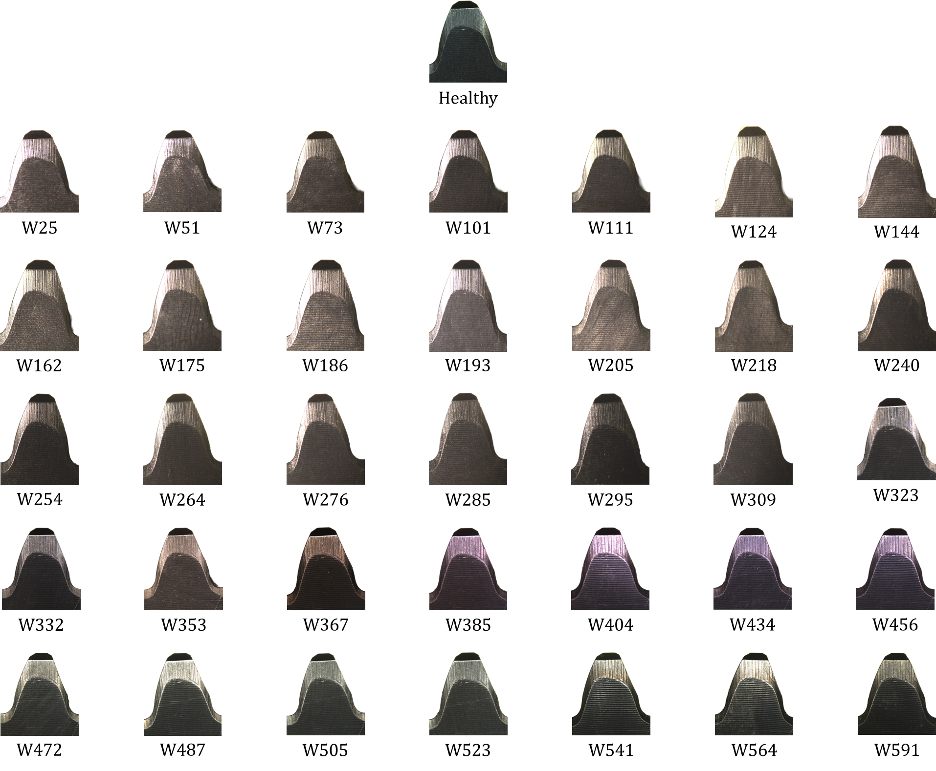

Figure : Face view of a gear tooth at all health status

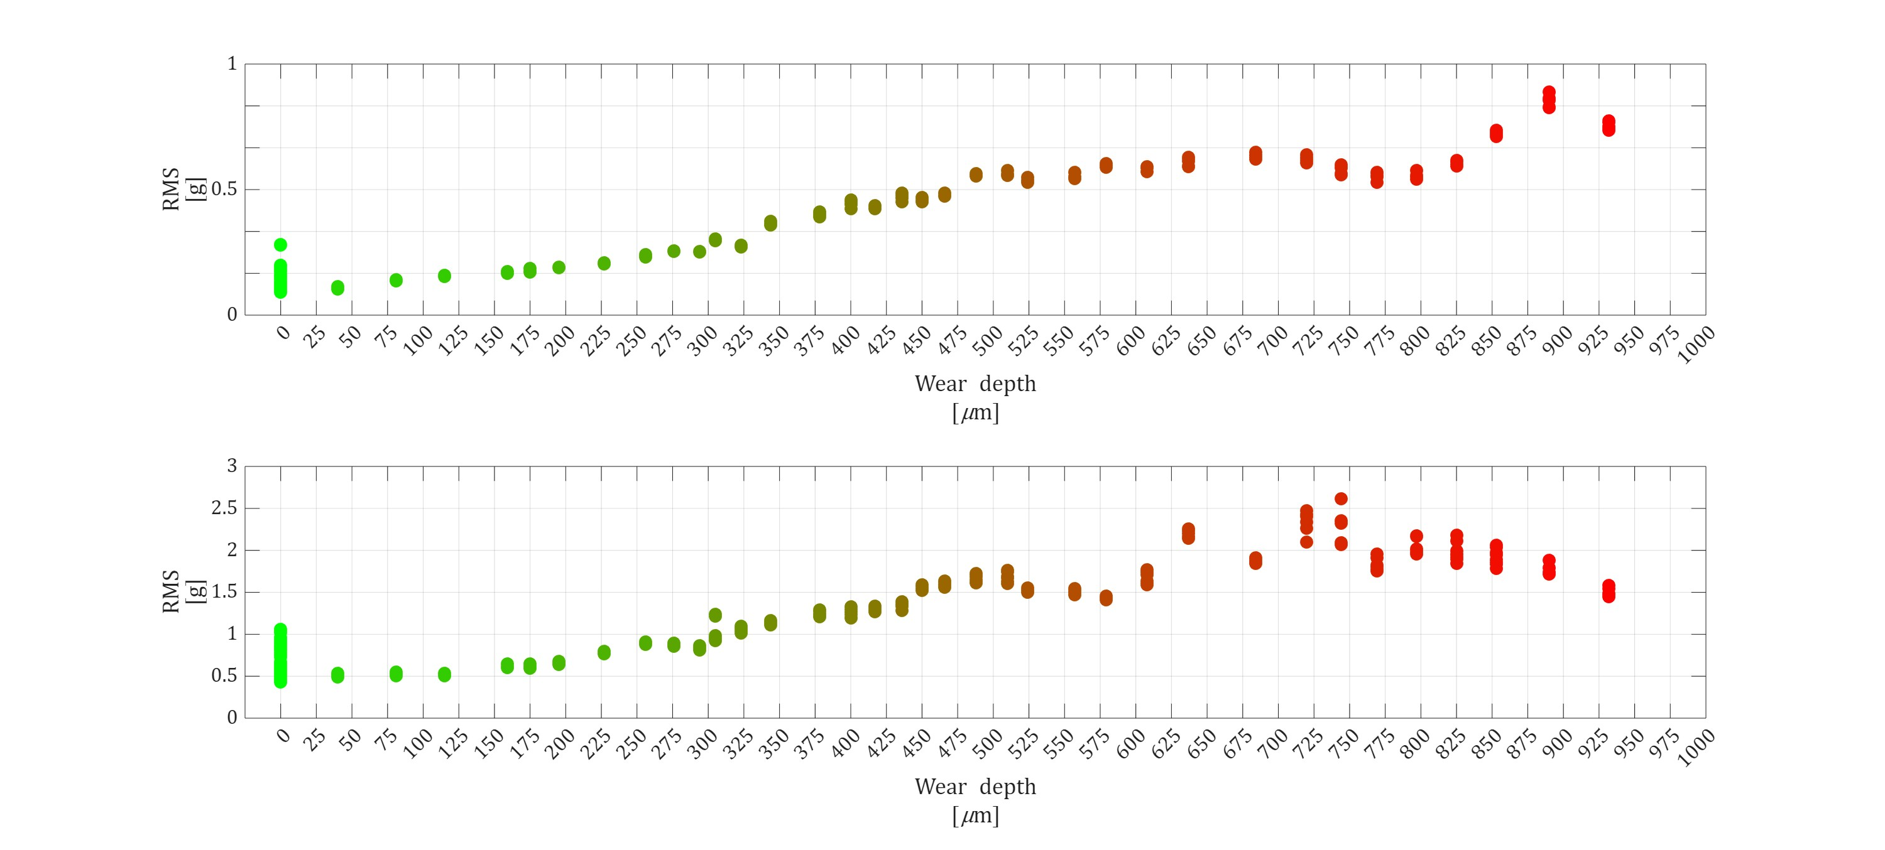

Figure : RMS level against wear depth at 15 [RPS] (above) and at 45 [RPS] (below). Healthy records are noted as zero wear depth.

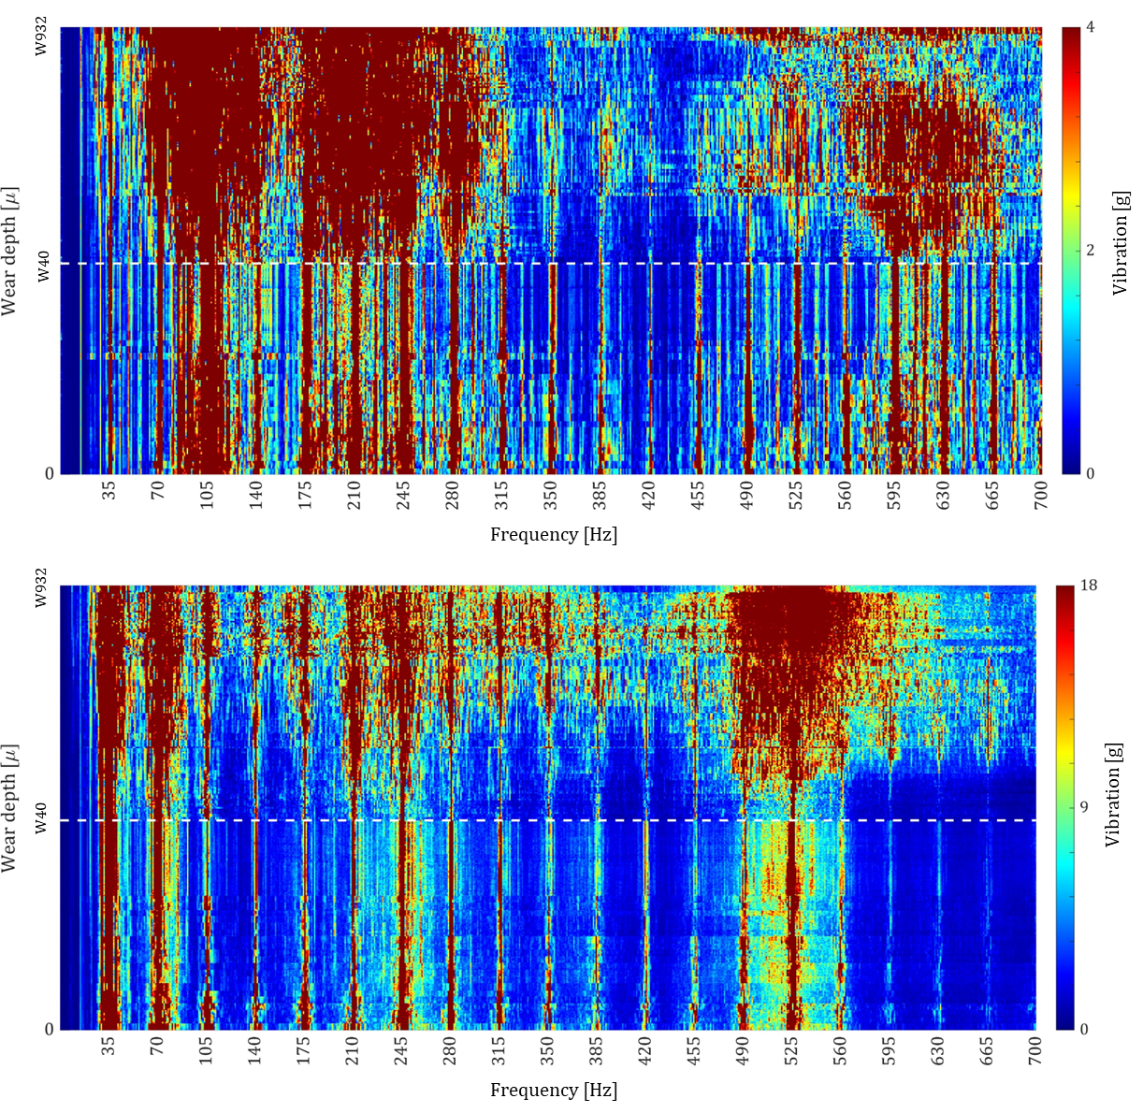

Figure : Fast Fourier Transform (FFT) spectrogram at 15 [RPS] (above) and 45 [RPS] (below). GMF harmonics are labeled on the horizontal axis, and the white dashed line marks the separation between healthy and faulty cases.

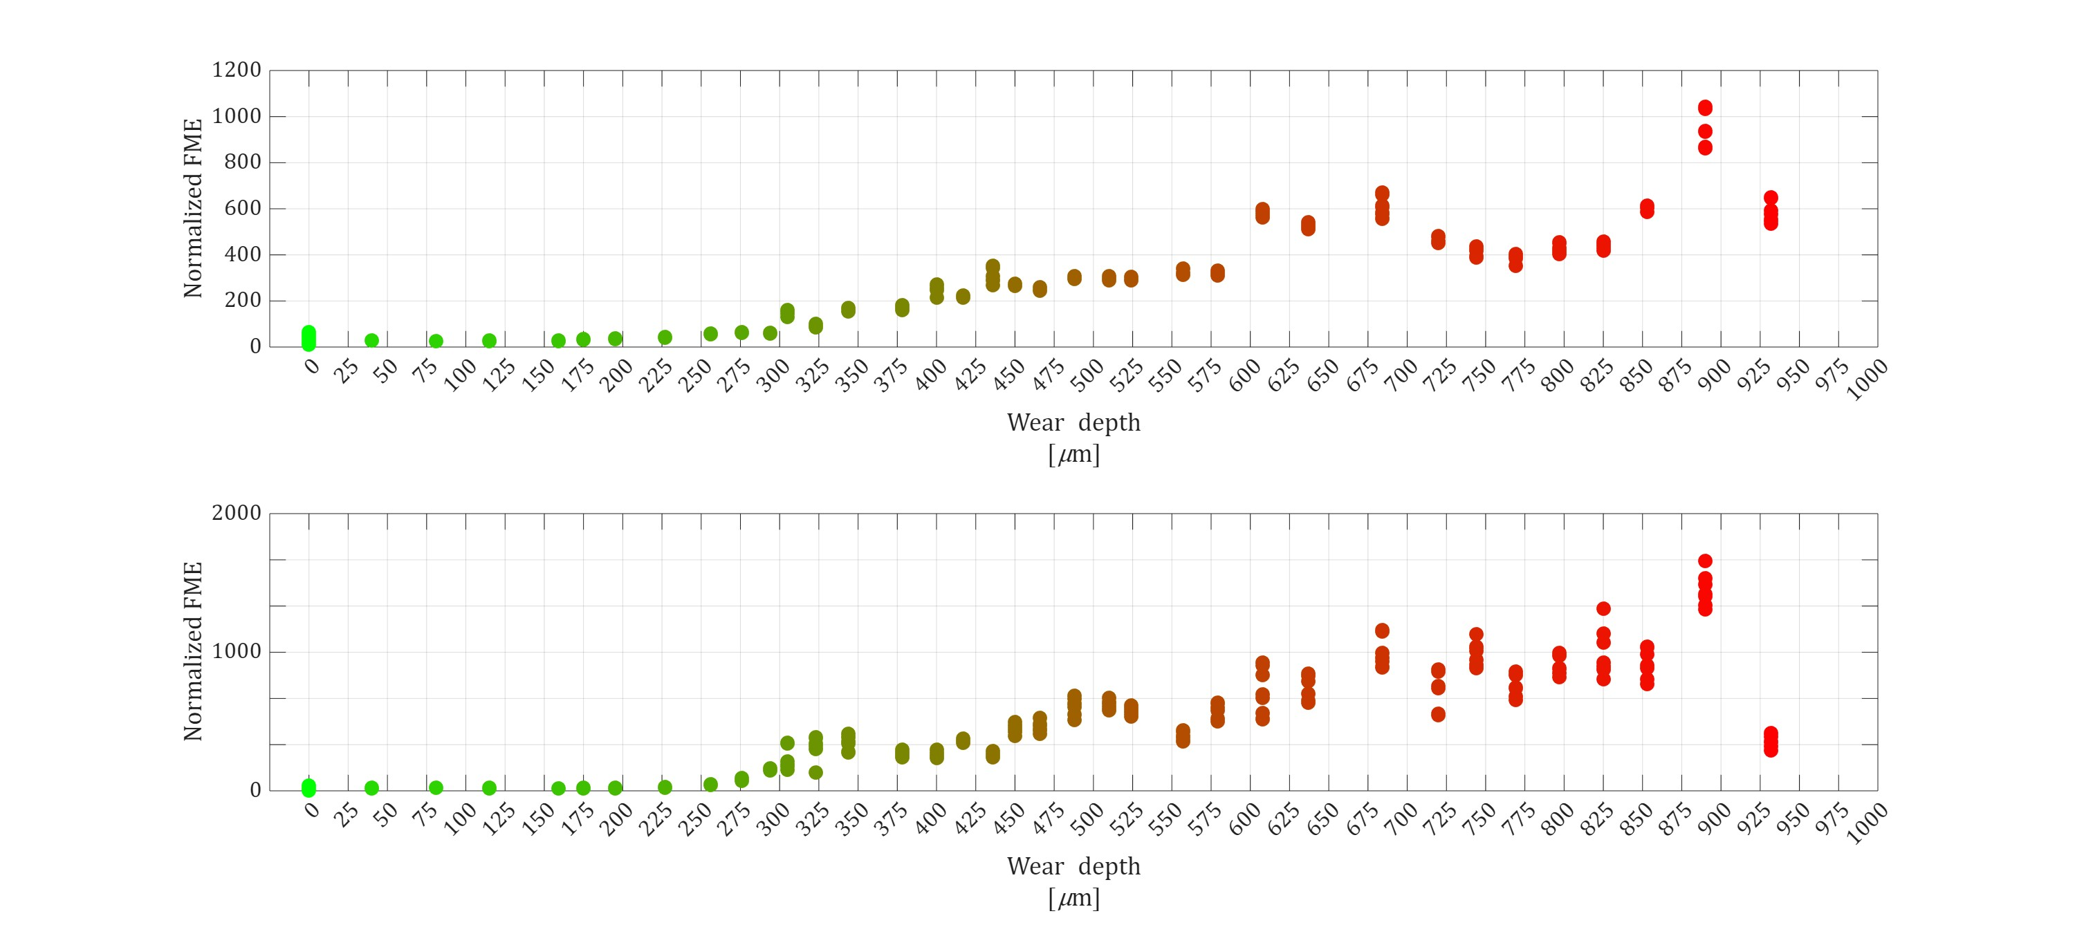

Figure : Normalized FME against wear depth at 15 [RPS] (above) and 15 [RPS] (below).